|  |  |  |  |  |  |
| --- | --- | --- | --- | --- | --- |
| Date | 13-Dec-22 | | | Tester Name | Richard Belanger |
| Environment | Penfax - Test | | | Login used | TEST2 |
| Operating System | Select OS | Version: | Update: | | |
| Software Used | Select Software | Version: | Update: | | |
| Select Software | Version: | Update: | | |
| Release version | 22.4.1 | | | | |
| Title | M27 Reversal and Adjustment through OLC and DCT | | | | |
| Test Type | Regression | | | | |
| Test Scenario | M27.05 Adjust a contribution | | | | |
|  |  | | | | |
| Expected Results | Contribution History should show the adjustment posting records.  Payroll History should show the difference of posted contribution and its details. | | | | |
| Pass/Fail | Pass | | | JIRA# | N/A |

Describe your steps with screenshots:

1. Bring up an active MEPP member and go to Contribution History.

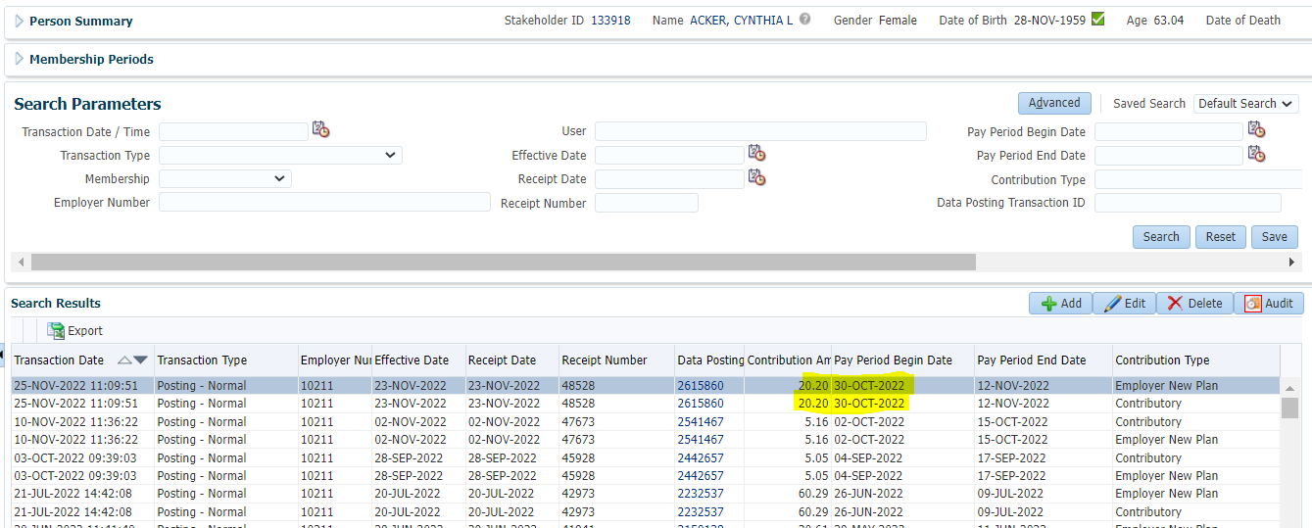

1. Go to Payroll History.

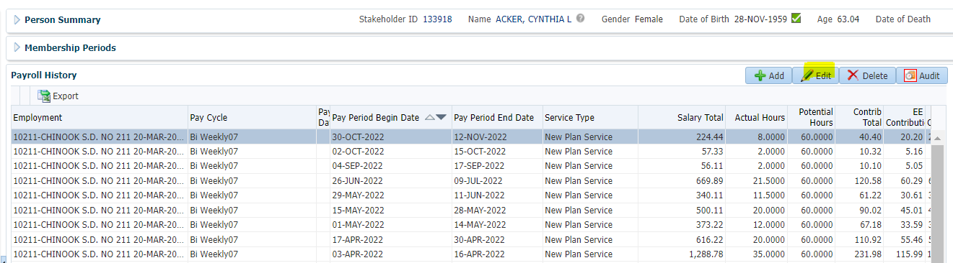

1. To adjust a contribution, highlight the record and then click on Edit.

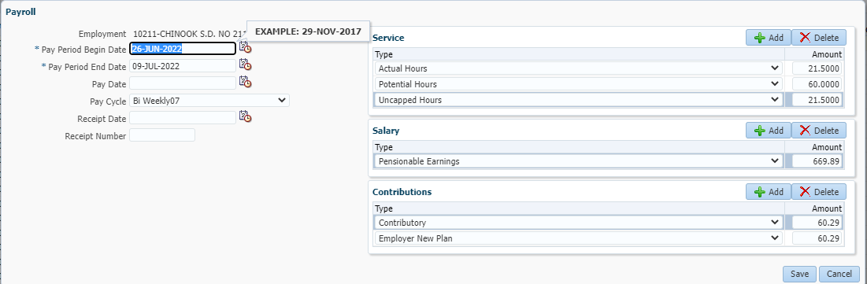

1. Update the contributions, leave other details as is and click on Save.

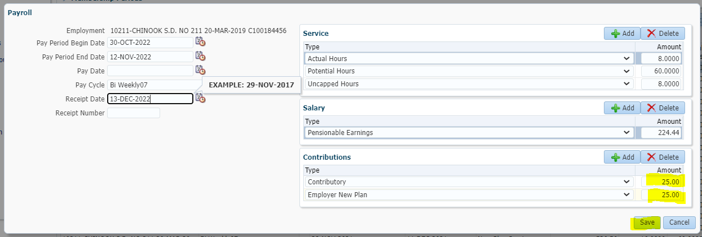

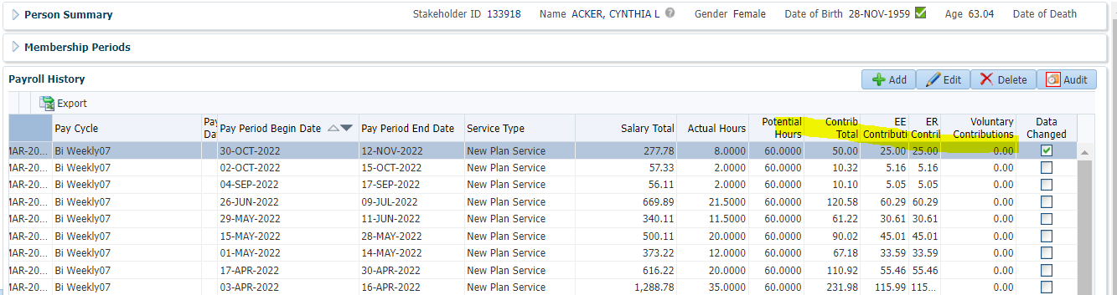

1. Go to Contribution History.

